Anantha Lakshmi Institute of Technology and Sciences (ALITS)
Department of Data Science

Visualizing Housing Market Trends: An Analysis of Sale Prices and Features using Tableau
Requirement Analysis — Data Flow Diagram & User Stories

Project Name: Housing Market Trends using Tableau
Team ID: ALITS-DS-2026-HousingMarketTrends
Academic Year: 2026

Data Flow Diagram & User Stories
High-Level Data Flow
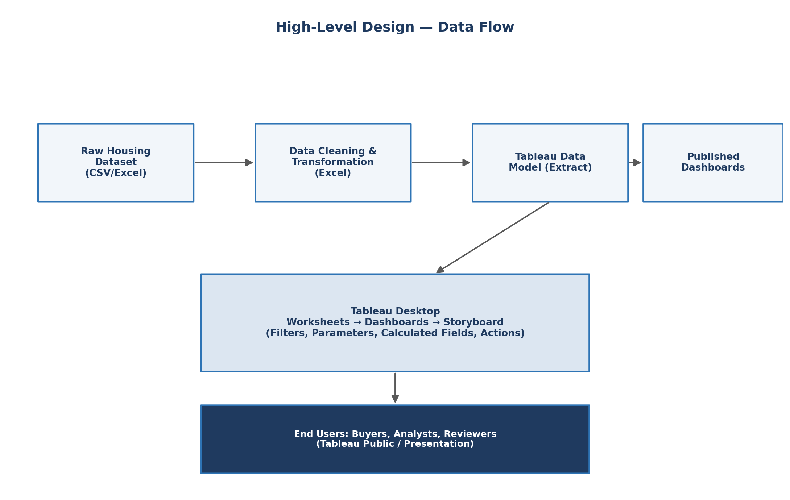
Figure 2.1: High-Level Data Flow — Housing Market Trends using Tableau
Raw housing data is cleaned and transformed in Excel into Transformed_Housing_Data_2.csv, imported into Tableau Desktop, modeled into worksheets (Sheet 1–4), assembled into the Comprehensive House Price Analysis dashboard (Dashboard 1), and narrated via the Story 1 storyboard before being published.
Data Flow Diagram — Level 0 (Context Diagram)
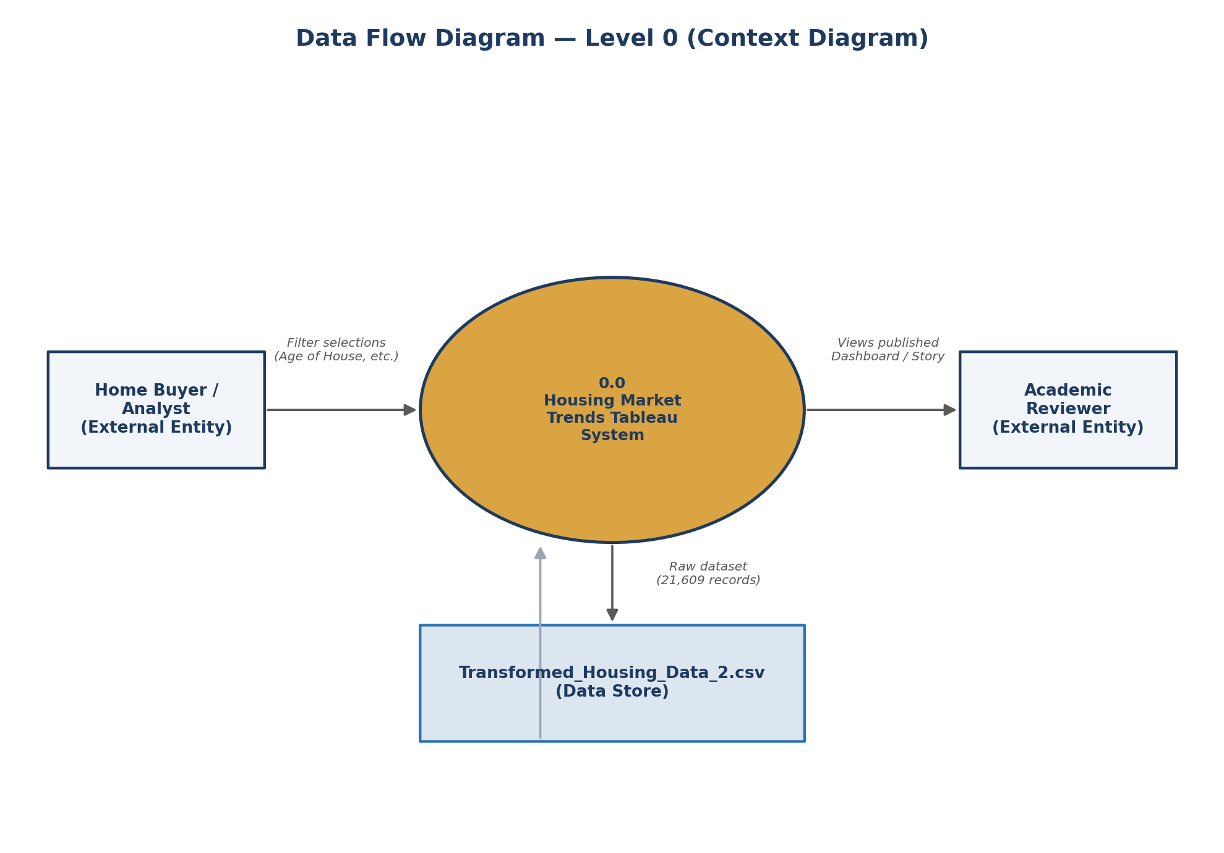
Figure 2.2: DFD Level 0 — Context Diagram
The Level 0 DFD shows the Housing Market Trends Tableau System as a single process, receiving the raw dataset from the data store, and exchanging filter selections and published views with the two external entities: Home Buyer/Analyst and Academic Reviewer.
Data Flow Diagram — Level 1
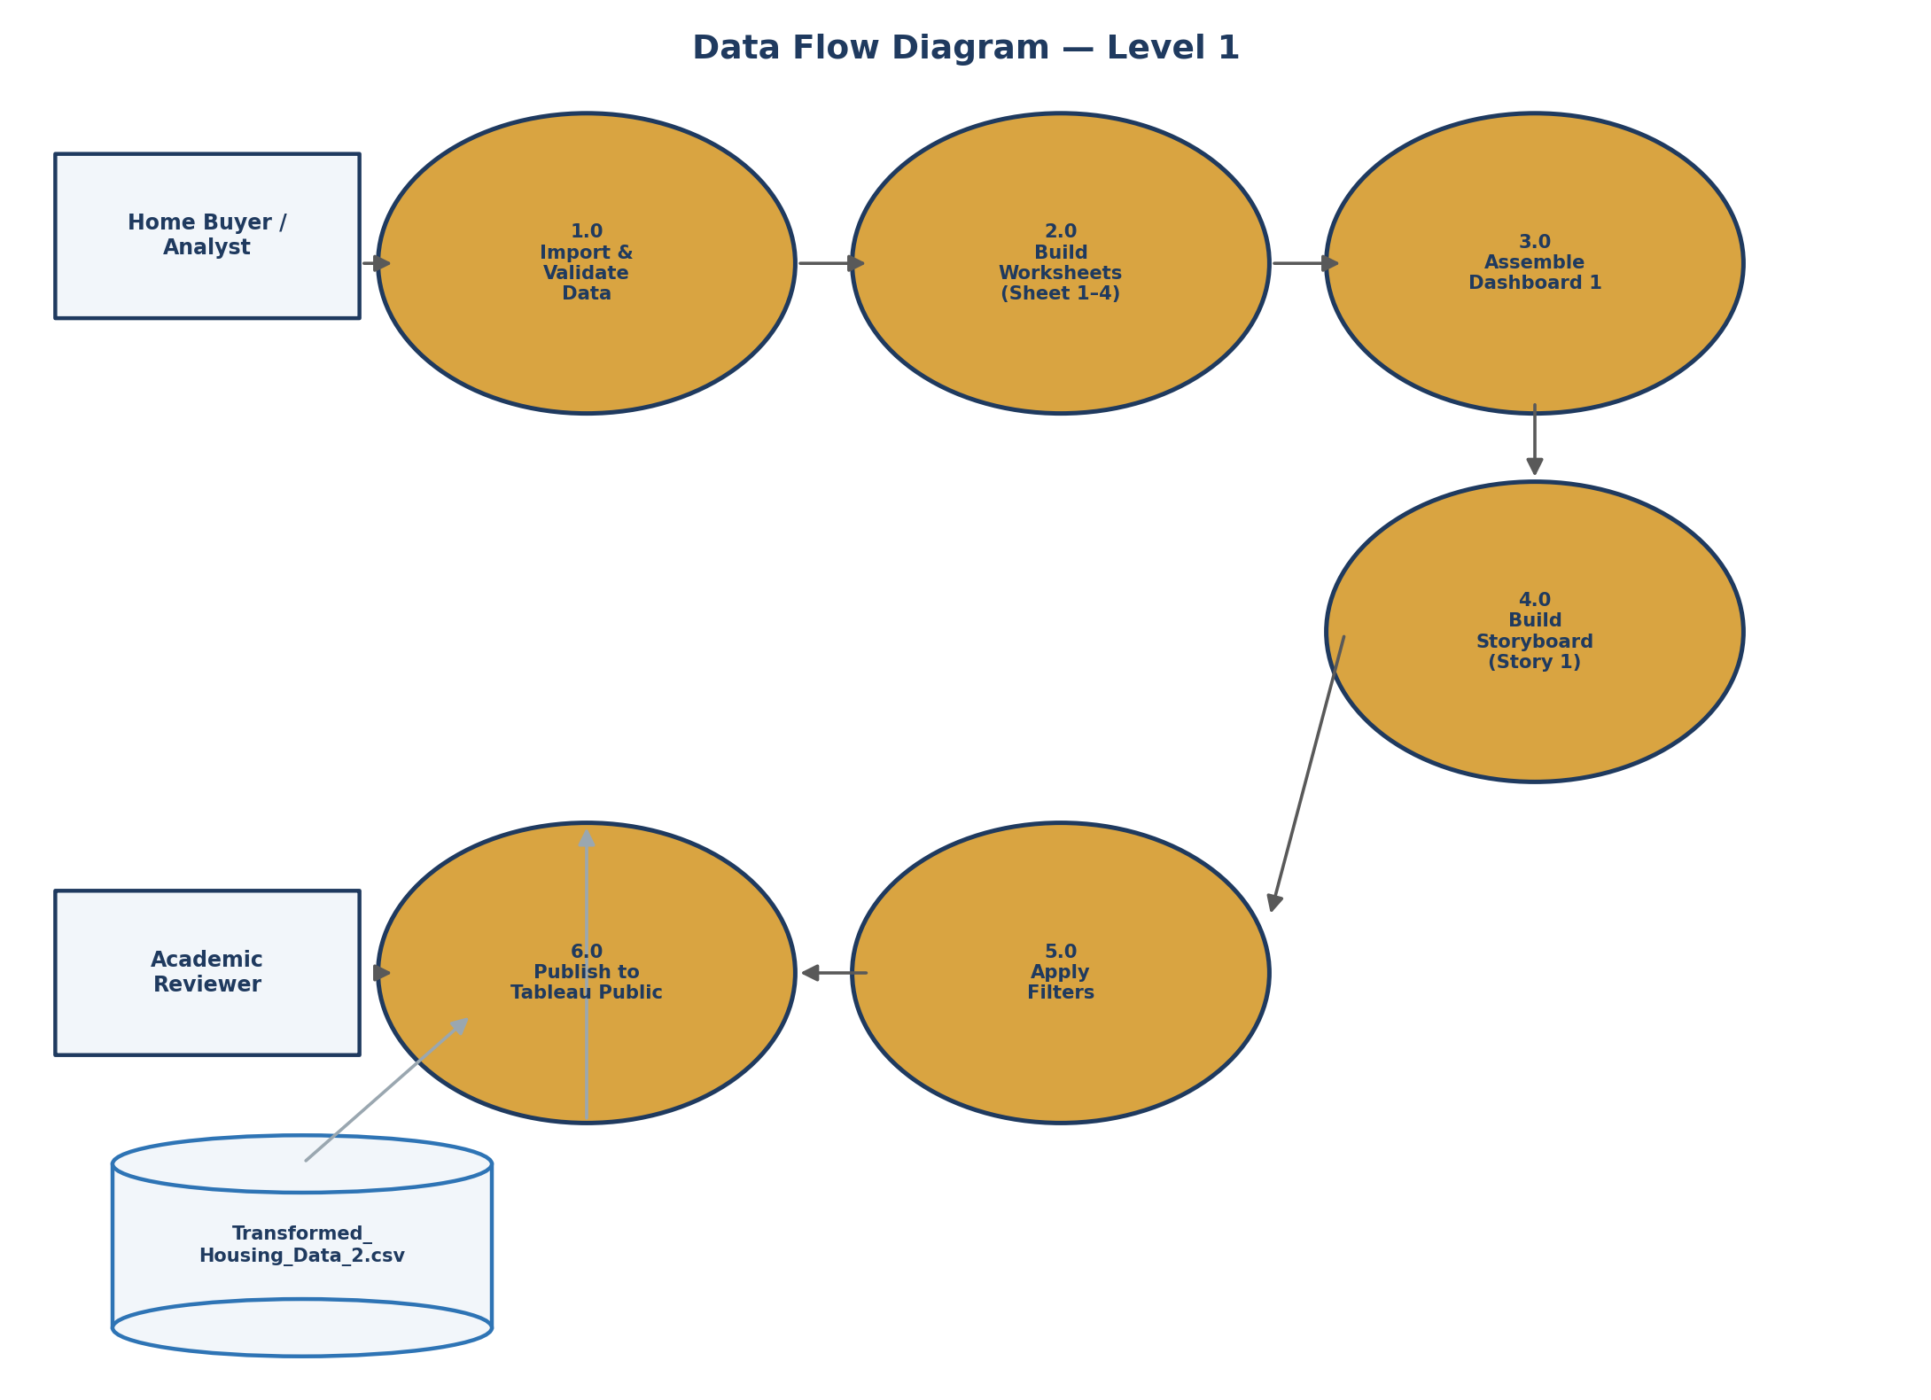
Figure 2.3: DFD Level 1 — Detailed Process Breakdown
The Level 1 DFD decomposes the system into six processes: (1.0) Import & Validate Data, (2.0) Build Worksheets, (3.0) Assemble Dashboard 1, (4.0) Build Storyboard, (5.0) Apply Filters, and (6.0) Publish to Tableau Public — showing how data moves from the CSV data store through to the published views consumed by the Home Buyer/Analyst and Academic Reviewer.
User Stories
User Story ID | As a... | I want to... | So that...
US-01 | Home buyer | see the total number of listings, total sale price, and total basement area at a glance | I can quickly gauge the scale of the market I'm browsing
US-02 | Real-estate analyst | view the distribution of sale prices as a histogram | I can identify common price ranges and outliers
US-03 | Home buyer | see how house age relates to renovation status | I can judge whether older homes have been kept up to date
US-04 | Analyst | compare bedrooms, bathrooms, and floors across house-age groups | I can understand how house configuration evolved over time
US-05 | Academic reviewer | view all key charts in a single dashboard | I can evaluate the project's insights without switching between sheets
US-06 | Any viewer | walk through a guided storyboard | I can understand the key takeaways without technical dashboard knowledge

